Edexcel GCSE - Business (9-1) worksheet
2.1.1. Business growth
Explain organic growth here:
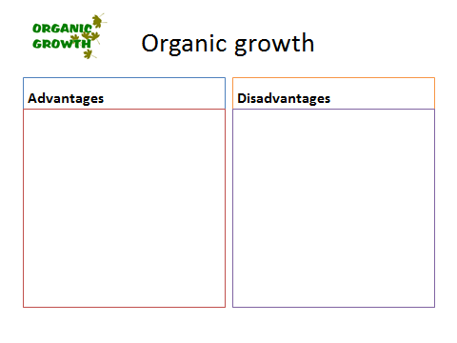
________________________________________________________________________________________________________________________________________________________________________________________________________________________________________________________________________________________________________________________________________

The two types of inorganic growth:
1
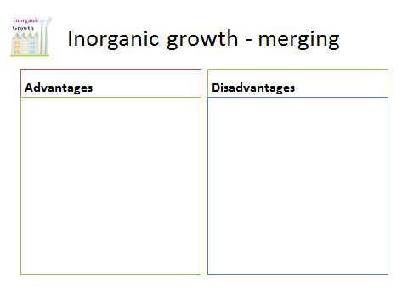
2

Explain a takeover here:
________________________________________________________________________________________________________________________________________________________________________________________________________________________________________________________________________________________________________________________________________
Becoming a plc
The two types of finance for growth:
1
2

Retained profits
Sale of assets

Loan capital
Share capital
Float on stock market

